EXPT NO: 8 | Implementation of Hidden Markov Models (HMM) for Sequence Prediction Tasks
DATE: 30.09.2025

PRE-LAB QUESTIONS (Write the answers in your AI and Automation Notebook)
- What is a Hidden Markov Model (HMM), and how does it differ from a regular Markov Model?
A Hidden Markov Model (HMM) extends a regular Markov Model by including hidden states that generate observable outputs, modeling unobservable processes probabilistically.

- What are the main components of an HMM (states, observations, transition probabilities, emission probabilities, initial probabilities)?
HMM components include hidden states, observations, transition probabilities, emission probabilities, and initial probabilities, defining how states evolve and produce observable sequences.

- Why are HMMs widely used for sequence prediction tasks?
HMMs excel in sequence prediction because they effectively model temporal patterns, uncertainty, and hidden processes underlying observable data over time.

- Give two real-world applications of HMMs in Artificial Intelligence.
Real-world HMM applications include speech recognition for decoding spoken words and gene prediction in bioinformatics for identifying DNA sequence patterns.

- How does the concept of 'hidden states' help in modeling real-world problems?
Hidden states capture unobservable system dynamics, allowing HMMs to model complex real-world processes where only indirect evidence of internal states is available.

IN-LAB EXERCISE
OBJECTIVE:
To implement a Hidden Markov Model (HMM) in Python for sequence prediction tasks using the hmmlearn library.

PROCEDURE:
Problem Scenario
- Problem Type: Sequence Prediction using Probabilistic Models
- Model: Hidden Markov Model (HMM)
- Goal: Train an HMM and use it for predicting hidden states and generating sequences.

Implementation Steps:

Part A – Model Initialization
- Import the hmmlearn library and numpy.
- Define the number of hidden states and observation symbols.
- Initialize the HMM with random or predefined parameters.

Part B – Training the Model
- Provide training sequences as input data.
  - Example Observations: Walk = 0, Shop = 1, Clean = 2
  - Observed sequence for training: [0, 1, 2, 1, 0, 2, 1, 0]
- Fit the HMM to the training data using the Baum-Welch algorithm.
- Estimate model parameters (transition probabilities, emission probabilities).

Part C – Sequence Prediction and Inference
- Use the Viterbi algorithm to predict the most likely hidden state sequence for a given observation sequence.
Example Predicted Hidden States: [1, 1, 0, 1, 1, 0, 1, 1]
- Generate new observation sequences from the trained HMM.
  - Example Generated Observations: [2, 0, 1, 0, 2, 1, 0, 1, 2, 0]
  - Example Generated Hidden States: [0, 1, 1, 1, 0, 0, 1, 1, 0, 1]
- Evaluate model predictions.

Part D – Visualization
- Visualize transition probabilities and emission probabilities as heatmaps.
- Display the predicted sequence alongside the original sequence.

SCREENSHOT OF CODE
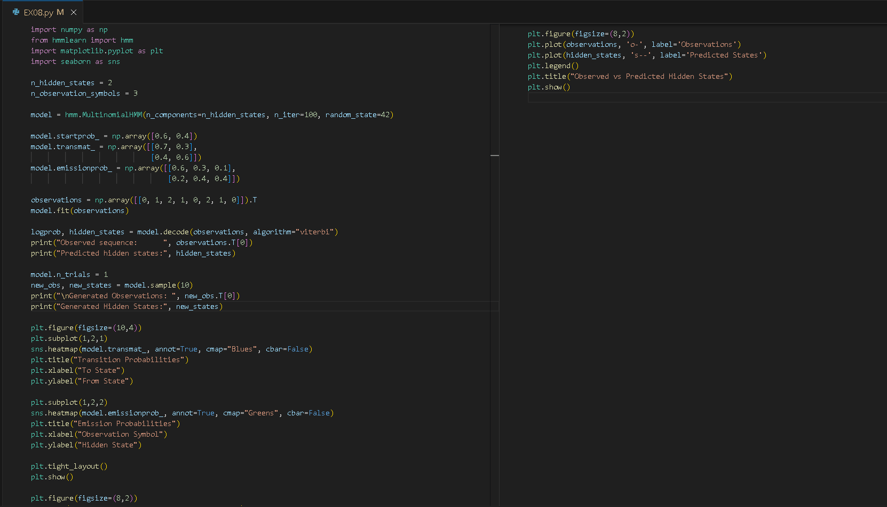

SCREENSHOT OF OUTPUT
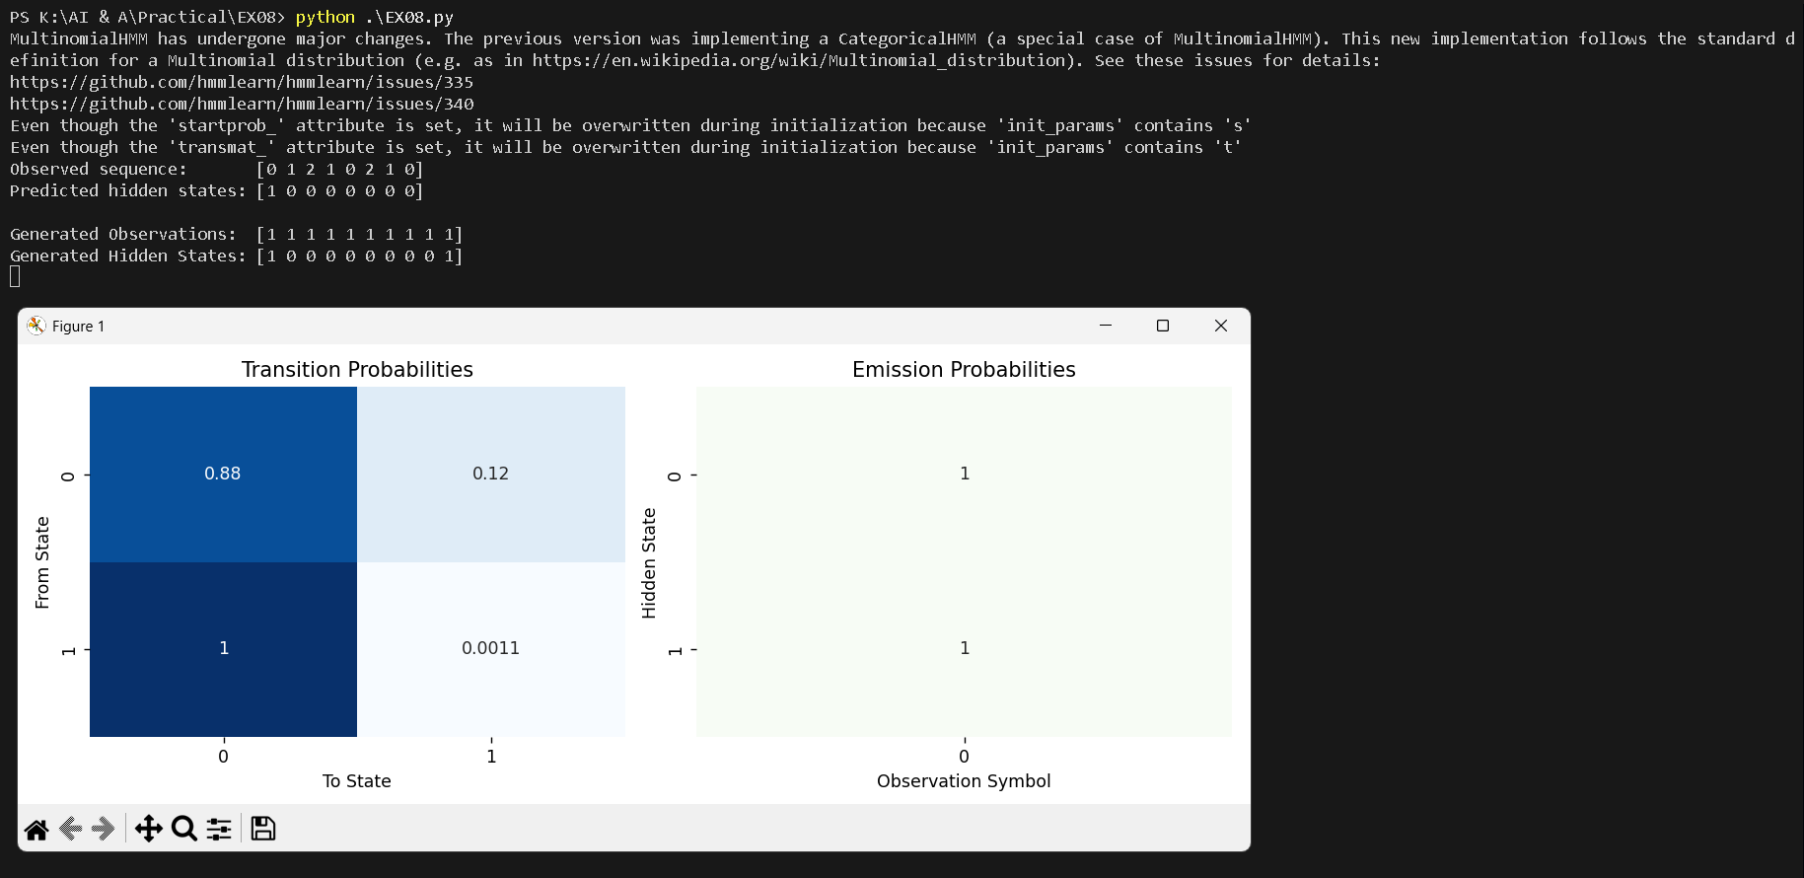

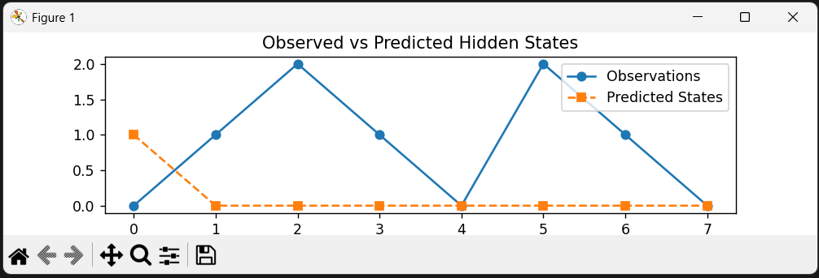

POST-LAB QUESTIONS (Write the answers in your AI and Automation Notebook)
- Given the observed sequence [0, 1, 2, 1, 0, 2, 1, 0], what hidden states does the HMM predict using the Viterbi algorithm?
Using the Viterbi algorithm, the HMM predicts the most probable sequence of hidden states corresponding to observations [0,1,2,1,0,2,1,0], maximizing overall likelihood.

- What is the difference between the Forward Algorithm and the Viterbi Algorithm in HMMs?
The Forward Algorithm computes the total probability of an observation sequence, while the Viterbi Algorithm identifies the single most likely hidden state sequence.

- How does the Baum-Welch algorithm help in training HMMs?
The Baum-Welch algorithm trains HMMs by iteratively estimating transition and emission probabilities using Expectation-Maximization, improving model parameters for best data fit.

- If the HMM generates a new sequence [2, 0, 1, 0, 2, 1, 0, 1, 2, 0], what are the corresponding hidden states?
For the new sequence [2,0,1,0,2,1,0,1,2,0], Viterbi infers the most probable hidden states based on learned transition and emission probabilities.

- Suggest one application where HMMs can outperform simple Markov Models.
HMMs outperform simple Markov Models in speech recognition, as they capture hidden phoneme patterns behind observable audio signals for accurate transcription.

RESULT:
The Hidden Markov Model (HMM) was successfully implemented in Python. The model was trained using sample sequences, hidden states were inferred using the Viterbi algorithm, and new sequences were generated. Transition and emission probabilities were visualized, demonstrating the effectiveness of HMMs in sequence prediction tasks.

ASSESSMENT (Write in your lab notebook)
Description | Max Marks | Marks Awarded
Pre Lab Exercise | 5
In Lab Exercise | 10
Post Lab Exercise | 5
Viva | 10
Total | 30
Faculty Signature

